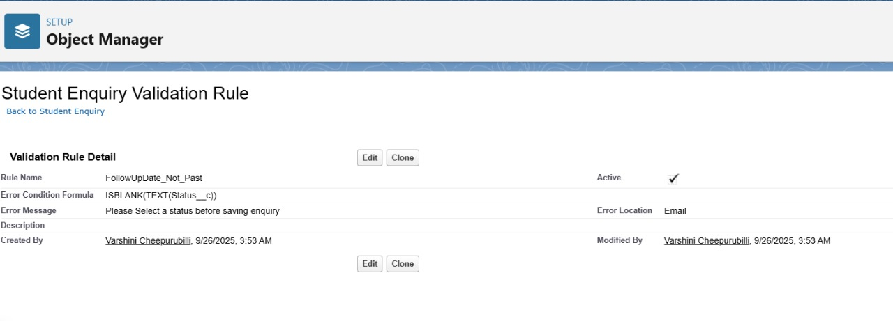
Phase 4 – Process Automation (Admin)
1. Validation Rules
Description:
Validation rules ensure data integrity by preventing users from entering invalid data.
Example: Prevent Follow-Up Date from being set in the past.
Implementation:
Setup → Object Manager → Student Enquiry → Validation Rules → New → Formula → Save

2. Workflow Rules
Description:
Workflow rules automate simple actions when criteria are met.
Example: Send email to counselor when Status = “New”
Implementation:
Setup → Workflow Rules → New Rule → Select Object → Define Criteria → Add Workflow Action → Save
3. Process Builder
Use Case / Description:
Process Builder automates multi-step processes like record updates and email alerts.
Example: When Status = “Converted”, create a Student record automatically.
Implementation:
Setup → Process Builder → New → Select Object → Define Criteria → Add Action → Save
4. Flow Builder
A. Record-Triggered Flow – Follow-Up Task Creation

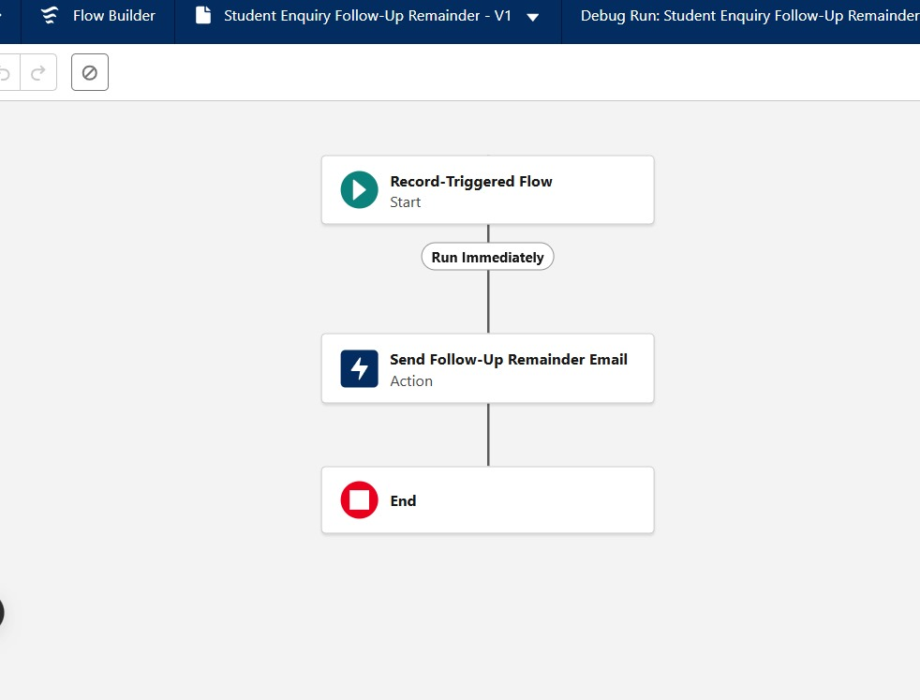
Description:
Automatically create a follow-up task when a Student Enquiry is created or updated.
Implementation Steps:
1. Setup → Flows → New Flow → Record-Triggered Flow
2. Object: Student Enquiry
3. Trigger: When record is created or updated
4. Condition: Follow-Up Date is not blank
5. Action: Create Follow-Up Task → Set fields (Related Enquiry, Due Date, Status)
6. Save → Activate

B. Email Alert for Follow-Up
Description:
Send an automated email to counselor when Follow-Up Date = TODAY.
Implementation Steps:
1. Setup → Email Alerts → New → Select Flow or Workflow
2. Action: Send email → Select template and recipient (Counselor)
3. Save → Activate

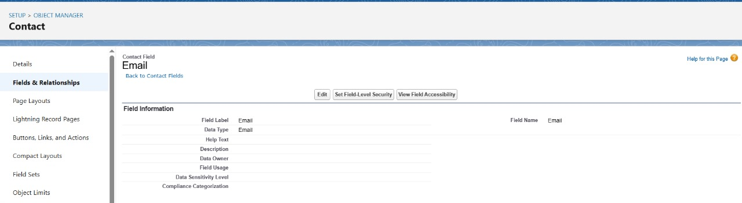

5. Tasks & Custom Notifications
Description:
Tasks track actionable items like follow-ups.
Custom notifications alert users in Salesforce when a follow-up is due.
Implementation Steps:
Setup → Object Manager → Follow-Up Task → New Field / Layouts
Setup → Notification Builder → New Custom Notification → Assign to Profile

